**Red Green Light**

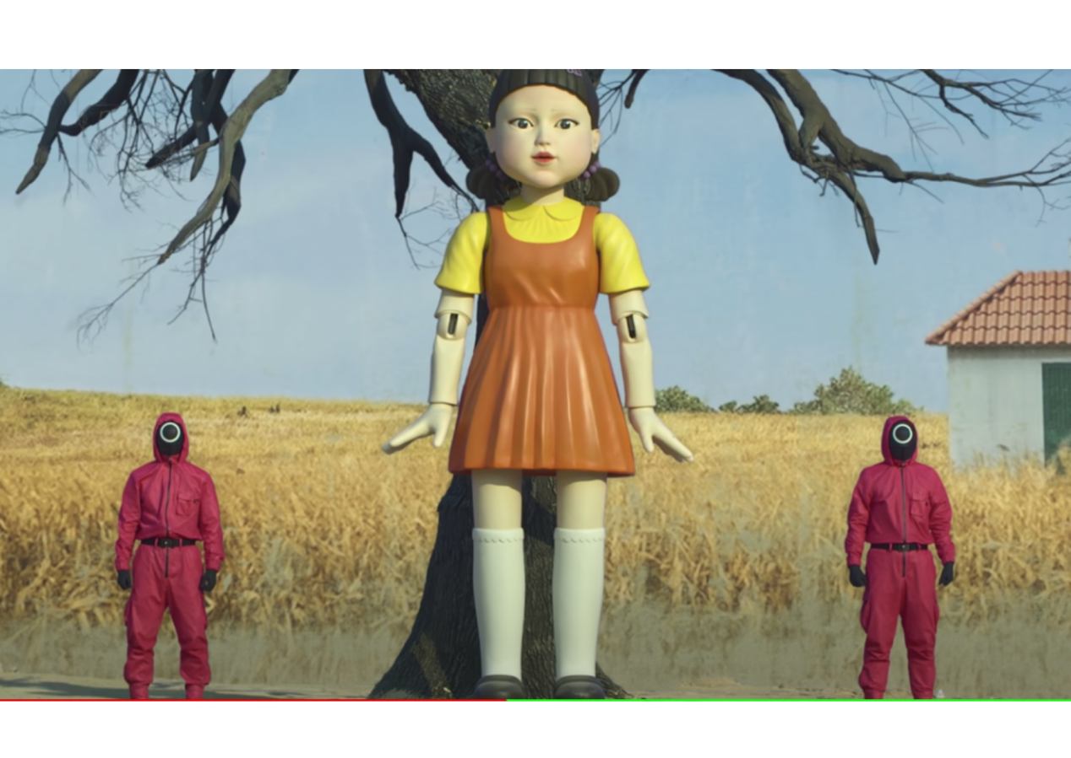

**Description**: A game where players move towards the "stoplight" when "green light" is called and must stop when "red light" is called.

**How to Play**: One player is the “stoplight” and stands at the opposite end of the playing area. They call out “red light” (everyone stops) and “green light” (everyone runs). The first player to reach the stoplight wins.

**Location**: Backyard, park, or any large outdoor area.

**Things Needed**: None.

**Players**: 3 or more.